# Guidelines for installing SQL Server 2019 and SQL Server Management Studio

This document contains guidelines for installing the needed software for the ["Databases Basics – MS SQL" course @ Software University](https://softuni.bg/modules/22/csharp-db-may-2024/1473).

|  |  |
| --- | --- |
|  | SQL Server Management Studio (SSMS) **18** works properly only with SQL Server **2019**.  SQL Server Management Studio (SSMS) **19 Preview** works properly only with SQL Server **2022.**  This guideline is for installing **SQL Server Management Studio (SSMS) 18** and **SQL Server 2019**.  If you'd like to use SQL Server Management Studio (SSMS) **19 (Preview)** version, download SSMS 19 from [here](https://learn.microsoft.com/en-us/sql/ssms/download-sql-server-management-studio-ssms-19?view=sql-server-ver15) and download SQL Server **2022** from[here](https://www.microsoft.com/en-us/sql-server/sql-server-downloads). The steps for installation are identical as the steps for SSMS 18 and SQL Server 19. |

## 1. Download and install SQL Server Express

### Step 1. Download SQL Server 2019 (Express edition)

Click on the link below from the Microsoft website and download **SQL Server 2019 Express:** <https://www.microsoft.com/en-us/download/confirmation.aspx?id=101064>. This should automatically download the installationfile. If it doesn't download it automatically, click on the **[Download]** button.

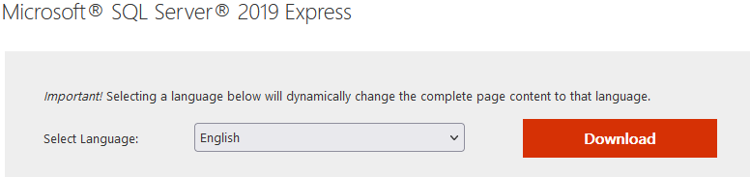

### Step 2. Install SQL Server 2019

Start the **downloaded** installation file. Choose the **Basic** option.

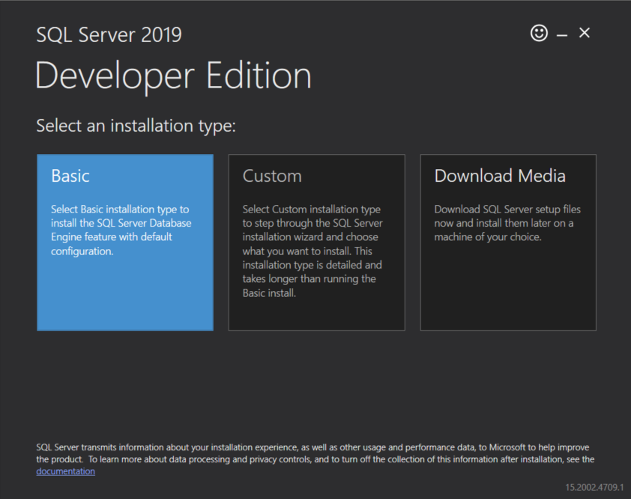

On the next screen, you have to **accept** the License Terms and Privacy Statement.

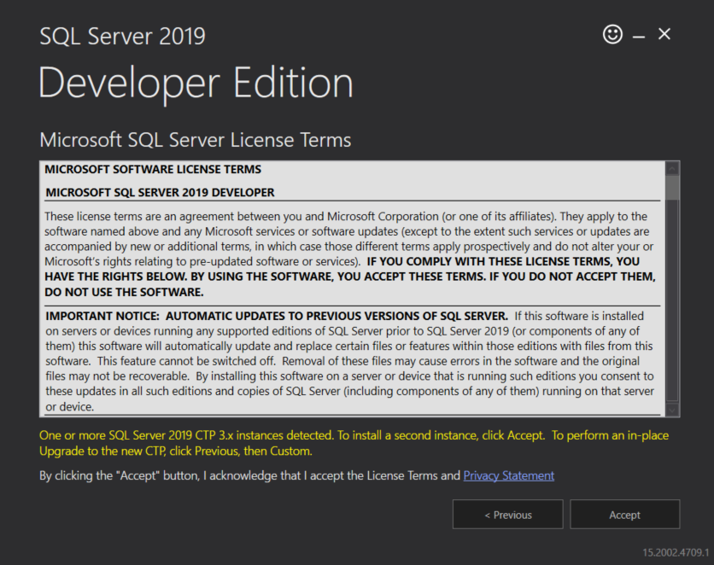

Before clicking on the **[Install]** button, you have to choose the directory to install the product to. You don't have to change anything, unless you have some specific preference. Graphical user interface, application

After the installation is successfully completed, you can use the **[Install SSMS]** button, which will take you to the Microsoft website in order for you to download the **SQL Server Management Studio** installer. You can find the same link in the next chapter of this document.

## 2. Download and install the SQL Server Management Studio

### Step 1. Download SQL Server Management Studio

If you haven't downloaded the installation file from the previous chapter, click on this [link](https://learn.microsoft.com/en-us/sql/ssms/download-sql-server-management-studio-ssms?view=sql-server-ver15) and download the **SQL Server Management Studio.**

### Step 2. Install SQL Server Management Studio

Open the downloaded installation file and click on the **[Install]** button. After the installation is completed successfully, you'll have to restart your computer.